* **Introduction**

As an owner of travel agency, I would like to provide recommendations for restaurants and some venues that are trending nearby hotels my customers pick to stay. When we travel a new location, it is time consuming and stressful for customers to plan and find where to visit for entertainment and restaurants. I would like to plan for them based on their interests so that my customers can be stress free from planning and enjoy their travel relaxing. I also would like to keep myself and staff up with the trendy venues so that we can have partnership with them and provide better service for my customers.

* **Data**

latitude, longitude, restaurants, and restaurant ratings, trendy locations, and tips are required. All data related to locations will be obtained via the Foursquare API utilized via the Request library in Python.

* **Methodology**

1. [Four square API Search Function 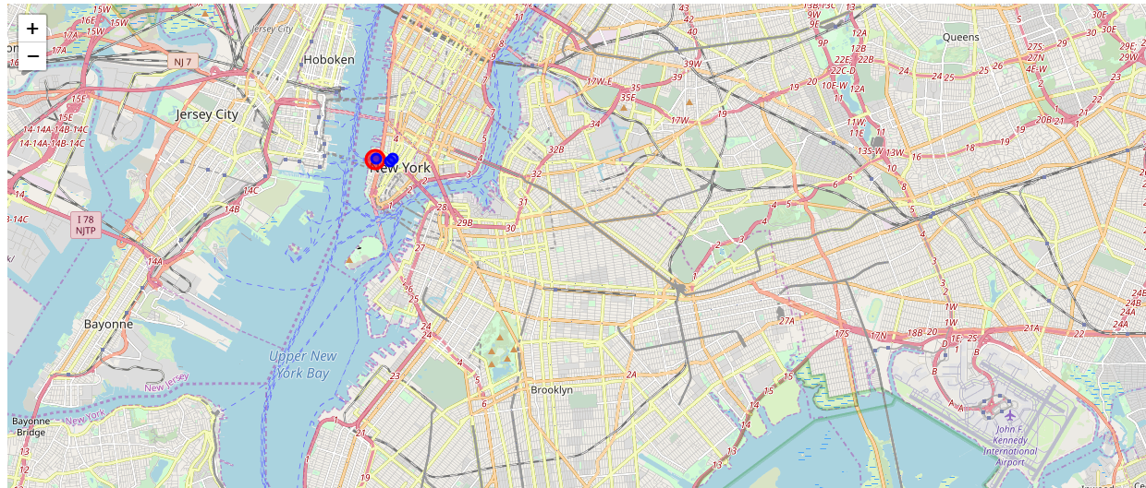](https://jupyterlab-2.labs.cognitiveclass.ai/user/ki2mj/lab#item1)
2. [Explore a Given Venue](https://jupyterlab-2.labs.cognitiveclass.ai/user/ki2mj/lab#item2)
3. [Foursquare API Explore Function](https://jupyterlab-2.labs.cognitiveclass.ai/user/ki2mj/lab#item4)

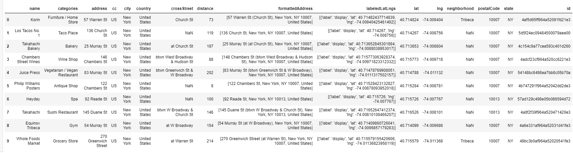

1. [Get Trending Venues](https://jupyterlab-2.labs.cognitiveclass.ai/user/ki2mj/lab#item5)

* **Results and Discussion**

Based on my customer's hotel location and food preference: Italian, we found an Italian restaurant Ecco that best fit to my customer's interest. However, Foursquare cannot recommend hot places to explore around after meal. To resolve it, I would go with other data source or upgrade the membership of Foursqure to have bigger data sets. In addition, I would consider building our own travel app for recommendations so that they can use it anywhere anytime.

* **Conclusion**

Providing recommendations for trending venues via our own app development will help us differentiate from our competitors.